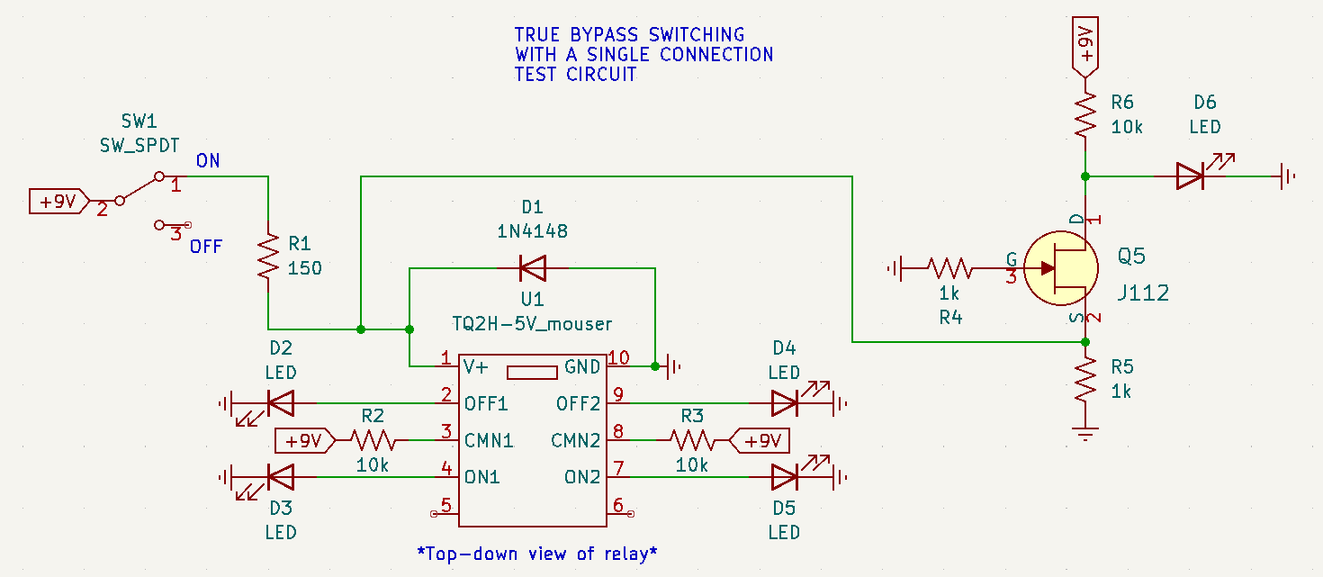This is the schematic for the test circuit used in the video. It uses LEDs so you can visually see how current is being routed.

This schematic details how to use a Panasonic TQ series relay to do true bypass switching in a real-world scenario.

